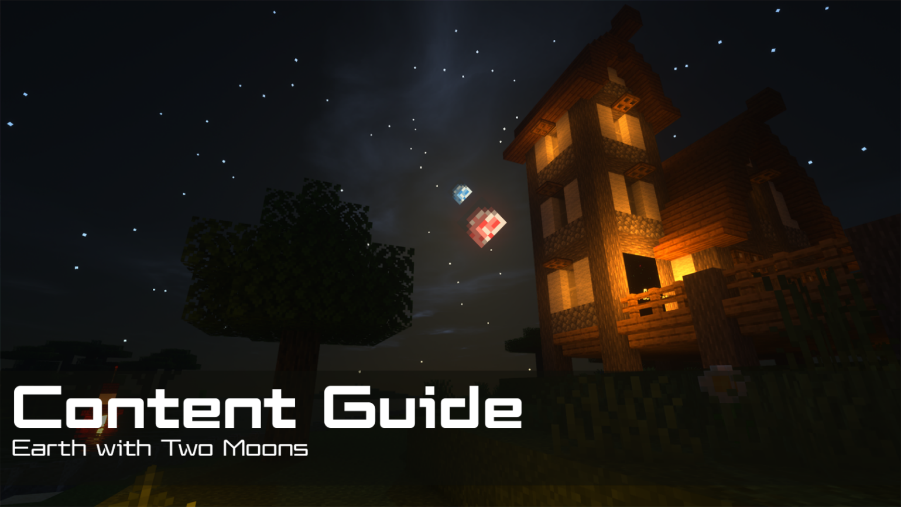
Contents  📖 Narrative Focus 3  World Overview 3  🎯 Objectives 3  🏫 Standards Alignment 4  📝 Assessments 4  💡 Tips for Instruction 5  🔭 Observable Concepts and Points of Interest 5  ❓ Expected Questions 6  🔬 Connected Classroom Activities 6  ☑️ World Quest Progression 7  🗺️ Maps 8  👩🏽‍🔬 NPC's and Their Roles 11 | How to Use This Guide  This content guide is intended for parents, librarians, teachers, and other educators who are interested in facilitating learning experiences with the WHIMC server, in home or classroom-based settings. It reviews all the critical components of a given WHIMC world as well as what might be learned in it.  This world is intended to be encountered after the initial tutorial and “What-If” worlds, for a full overview of world order, see the teacher guide home page.  More information about project WHIMC can be found on our website at whimc.org. Teachers and participants unfamiliar with computer-based Minecraft: Java Edition can learn how to install and control the game here as well.

📖 Narrative Focus
A world working to understand and cope with rising tides and volcanic moons. Gravity can pull on more than just oceans! In a sense it’s the opposite of no moon but still just as volatile.

World Overview
This Earth has captured a second moon, similar in size and mass to the original, orbiting at roughly half the distance. The combined tidal pull reshapes the planet, its days, and life on its coasts.

Bigger Tides
- The second moon orbits about twice as close, so its tidal pull is much stronger.
- Combined tides run roughly six times greater than Earth's today.
- Coastlines flood and drain over huge ranges, making permanent coastal living difficult and constantly reshaping shorelines, estuaries, and tidal flats.

A Much Longer Day
- The strong tidal interaction alters Earth's rotation, stretching the day to about four times our own (on the order of ~96 hours).
- Longer days mean longer, hotter daytime heating and longer, colder nights.
- Weather, plant rhythms, and animal behavior all reorganize around this extended cycle.

Heightened Geologic Activity & a Crowded Sky
- Stronger, competing tidal forces flex the planet's interior more, raising the potential for increased seismic and volcanic (tectonic) activity.
- Two moons share the sky, producing complex phases, more frequent eclipses, and intricate combined tidal patterns.
- Surface gravity stays Earth-normal — it's the tides and day length, not your weight, that change.

🎯 Objectives
- Students will learn about the moon's effects on Earth, including details about tides, reflecting sunlight light at night, and slowing the rotational speed of Earth with its gravitational pull.
- Students will also learn about how coastal towns try to mitigate the effects of erosion caused by tides and water level changes.

🏫 Standards Alignment
Next Generation Science Standards (reference)
- K-ESS3.B: Natural Hazards
- 1-ESS1.A: The Universe and its Stars
- 1-ESS1.B: Earth and the Solar System
- 3-ESS3.B: Natural Hazards
- 4-ESS2.B: Plate Tectonics and Large-Scale System Interactions
- 4-ESS3-2: Generate and compare multiple solutions to reduce the impacts of natural Earth processes on humans
- 4-ESS3.B: Natural Hazards
- 5-PS2.B: Types of Interactions
- 5-ESS1-2: Represent data in graphical displays to reveal patterns of daily changes in length and direction of shadows, day and night, and the seasonal appearance of some stars in the night sky.
- 5-ESS1.A: The Universe and its Stars
- 5-ESS1.B: Earth and the Solar System
- MS-ESS1-1: Develop and use a model of the Earth-sun-moon system to describe the cyclic patterns of lunar phases, eclipses of the sun and moon, and seasons.
- MS-ESS1-2: Develop and use a model to describe the role of gravity in the motions within galaxies and the solar system.
- MS-ESS1-3: Analyze and interpret data to determine scale properties of objects in the solar system.
- MS-ESS2-6: Develop and use a model to describe how unequal heating and rotation f the Earth cause patterns of atmospheric and oceanic circulation that determine regional climates.
- MS-ESS2.C: The Roles of Water in Earth’s Surface Processes
- MS-ESS2.D: Weather and Climate
- MS-ESS3.D: Natural Hazards
- MS-ESS3.D: Global Climate Change

📝 Assessments
During WHIMC camps, instructors provide opportunities for students to express what they have learned in the form of short answer questions. Over time, these have taken two forms: ICAN Prompts and Self-Explanations. While teacher content guides are designed for those outside of WHIMC researcher-run camps, these prompts can be used to facilitate discussions about the server and what was learned during a playthrough of a particular world.
Self-Explanations
Two Moons Questions | Why are tides higher with two moons? | Besides the number of moons, what is different from No Moon? | Why is one moon's surface covered in volcanoes?
Possible Answers | Each moon contributes to the tides. The closer one, when half the distance as our present moon, will by itself create tides 8 times higher than tides today. | Massive tidal shifts, more light at night, rotation speed and year cycles, wind | Changing gravitational pulls of Earth and other moon would cause that moon to change shape asit orbits. The resulting friction from changing shape would heat the planet, and volcanoes would form to release the internal liquid rock
Earth with Two Moons is an optional What-If world in the quest series but contains Lunar Loop, which indicates if participants have explored both museums and the volcanic moon, a good indicator of engagement. There are two other quests contained within it, Seeing Double and What’s the Time, that also prompt players to engage with core science concepts.
On every world there are main concepts and science variables that can be observed. Instructors can expect a minimum of 3 observations of substantive quality and 3 different science measures to consider a learner to be at a level of satisfactory engagement on Earth with Two Moons.

💡 Tips for Instruction
- Earth with Two Moons has three distinct parts - the first is nighttime in a town during a high tide period, the second is the same town during a low tide period, and the third is a "VR" simulation of what it is like on one of the moons, called Lluna. Make sure students explore every available area and complete all available quests!
- The "VR" simulation is located in the dome-shaped museum, but it is only staffed during the high tide period. Players can notice the different locations of the moons in each iteration.
- Make sure resource pack downloading is turned on, as this is how the two moons show up in the sky.

🔭 Observable Concepts and Points of Interest
Global Impacts
/tides - Over 6 times greater than the variance of Earth
/daylength (rotational_period) - 96 hours
/tectonic - elevated relative to Earth (stronger tidal flexing)
Light at night is much brighter
Few stable marshes/estuaries; settlements pushed inland or elevated
Oceans
/temperature - Warmer than air temperature
/pressure - Increases the deeper the player goes
Lluna
Visible volcanoes!
/temperature (when very close to volcanoes) - Very hot / heat radiates poorly in vacuum!
Visible geographic features
Buoy and retaining walls relative to water height (tides)
Displays in the museum
Traveling through time effects

❓ Expected Questions
Questions Kids Might Ask | Questions Facilitators Might Ask
How are there two moons here?  What are the moons called?  Why are the tides so high?  How do the moons move? Do they affect one another?  Could we actually live with two moons?  Why are there volcanoes on Lluna?  Does the length of day (or year) change here?  What is the rotational speed of the planet then?  Why is one moon red? | What other effects do you think having two moons might have on our world?  How might the greater tides affect us in other ways? Think about erosion or sea levels.  How does having two moons affect the Earth and the different plant life and animal life?  Was there anything in this level that surprised you?  Where did you explore? Who did you meet?  What questions do you have?

🔬 Connected Classroom Activities
Live ball + flashlight activity to highlight how the light is affected on Earth by both moons
Discussions and explorations about tide and ways that the moon affects Earth
Exploring the possibility of a double eclipse through hands-on and interactive means

☑️ World Quest Progression
There are just two optional side quests on this world that players can explore as they traverse it, encountered in-sequence as they go between times of the day, as well as the overarching exploration tracking quest.

🗺️ Maps
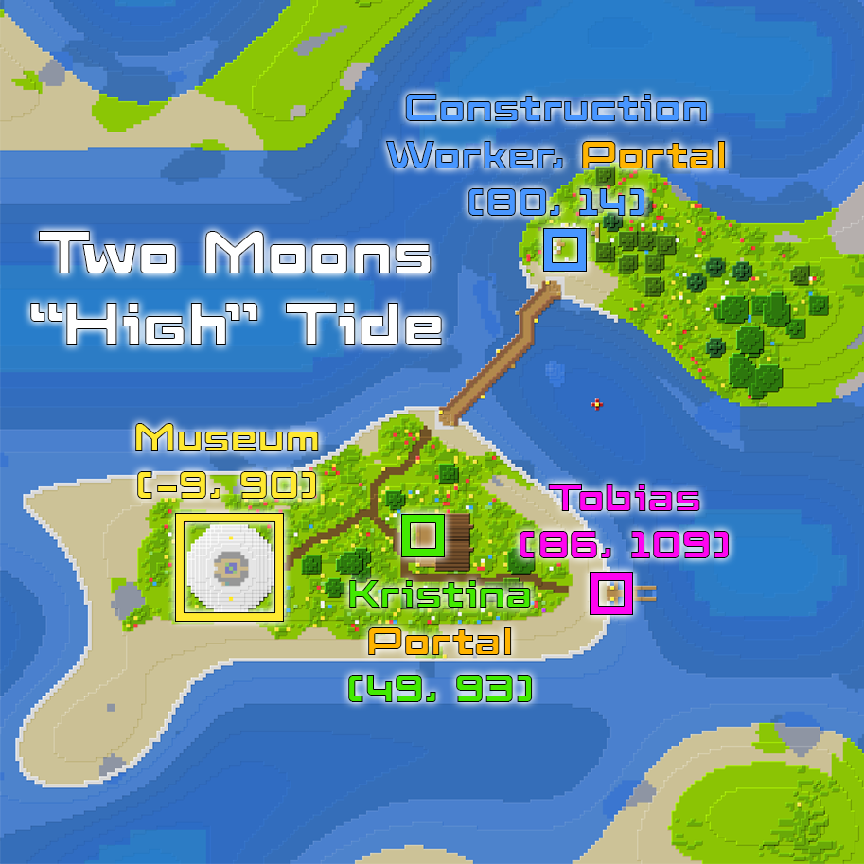
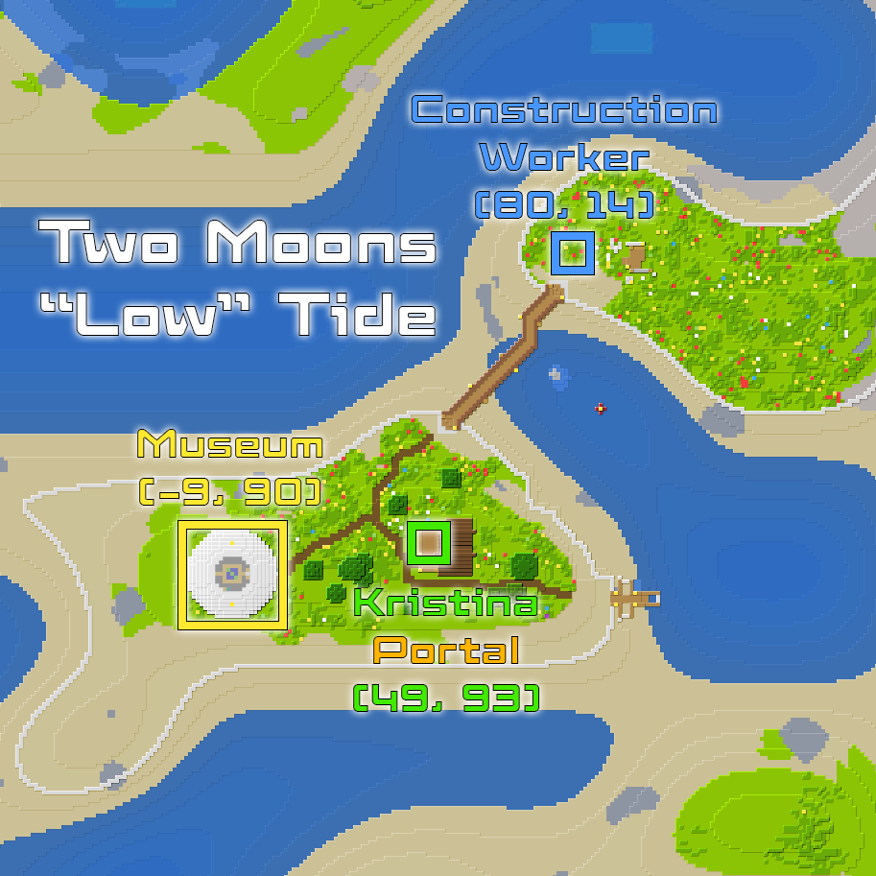
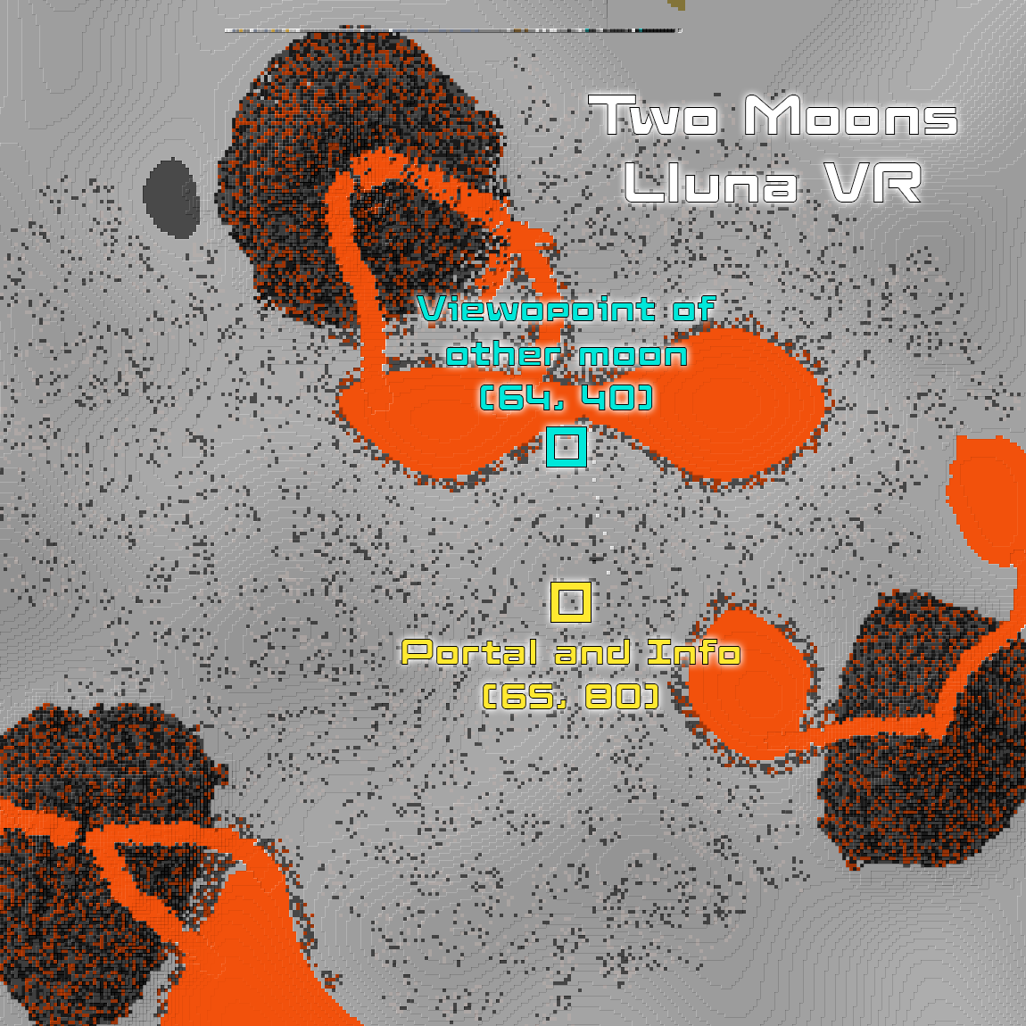

👩🏽‍🔬 NPC's and Their Roles
A non-player character (NPC) is a video game character that is controlled by the game's artificial intelligence (AI) rather than by a player. The NPC’s below are those that are tied to quests on the server or that offer relevant STEM information – there are others who may be present but not mentioned in this guide.
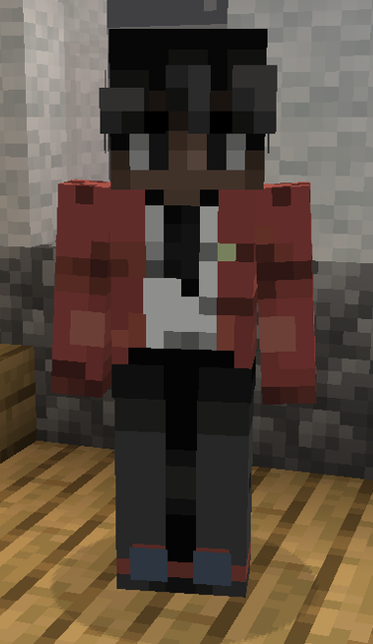 | Located at  x: ~45  y: 69  z: ~93  ID: 197, 198 | Kristina - Tells players that the tides are currently at their highest point. Gives quest Seeing Double, and prompts players to talk to Tobias at the docks to continue the quest. Later she suggests they check the time for the What’s the Time quest to notice the difference in the length of day.
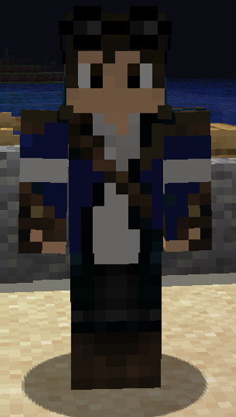 | Located at  x: 86  y: 63  z: 109  ID: 199 | Tobias - Tells players about the concrete walls intended to help protect against erosion, as well as the second part of the Seeing Double quests, with a prompt to measure tides.
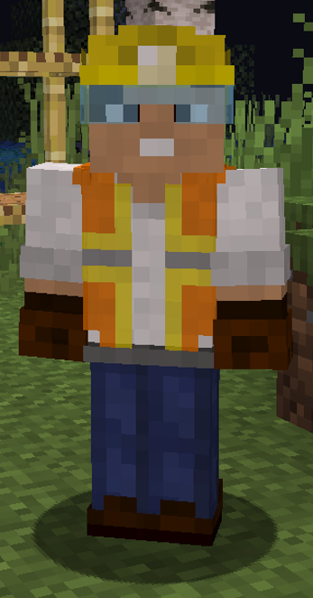 | Located at  x: ~88  y: ~67  z: 13  ID: 222, 223 | Worker – Initially during high tide they talk to players about the difference in brightness here versus on normal Earth, stands near the portal needed to progress the Seeing Double quest. Later, when players return they talk about being done working for the day due to being all out of building materials to help emphasize the passage of time.
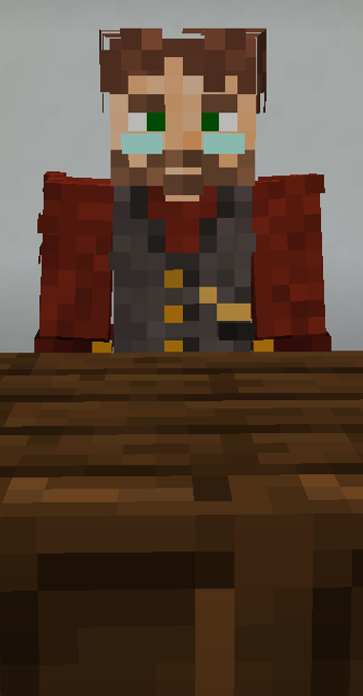 | Located at  x: -9  y: 66  z: 90  ID: 225 | Joel - Museum attendant, has a brief overview of the museum's purpose and features when players look at him, prompts players to explore the "VR" Lluna. Only present during high tide.
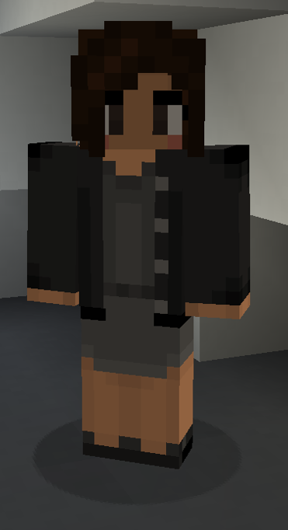 | Located at  x: -6  y: 71  z: 106  ID: 226 | Kate - Provides more information surrounding the size and orbit of Kuu and Lluna. Only present during high tide, but her prompting hopefully cues players to pay attention to the alternative moon positions during the low tide period.
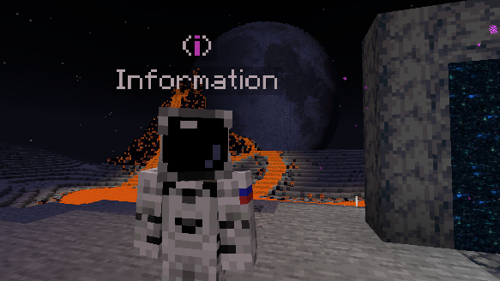 | Located at  x: 65  y: 86  z: 80  ID: 231 | Lluna Astronaut – Explains the volcanic forces and conditions that make Lluna different than our moon.

